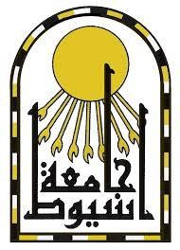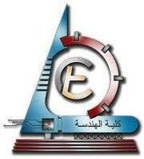

Gehad mostafa kamel ahmed
Mining & Metallurgical Engineering Department Faculty of Engineering, University of Assiut  Assiut, Egypt. | Phone: | +20-1009464683  +20-1067746468
 | E-mail: | gehad.mostafa@aun.edu.eg
 |  | gehad.mostafa1@yahoo.com

PERSONAL INFORMATION:
- Sex : Female
- Marital Status : Married
- Nationality : Egyptian

EDUCATION:

- 2010-2014: Bachelor’s Degree in Mining & Metallurgical Engineering, Assiut University, Egypt.
General grade unit: Excellent with Honor's degree.

- 2012-2013: Project in Mine Surveying for a month in the red sea area [Mine Surveying Project].

A CAREER TRANSCRIPT:

     2020 to present: Assistant Researcher and Lecturer, Faculty of Engineering, Assiut University, Egypt.

     2014 - 2020: Demonstrator (Teaching and researcher assistant) ,Faculty of Engineering, Assiut University, Egypt

